API Security Risk Analysis Report

Prepared by: Huma Ameer
Prepared for: Future Interns Cybersecurity Internship
Date: 18 July 2026

Table of Contents
Executive Summary 3
Introduction 3
Objective 4
Scope and Ethical Considerations 4
Tools Used 5
Methodology 5
API Testing and Evidence 6
Cat Facts API Documentation Review 6
Test 1: Random Cat Fact Request 6
Test 2: Random Cat Fact Request with max_length parameter 7
Test 3: Multiple Cat Facts Request 7
Test 4: Input Validation 8
Response Headers Review 10
Authentication and Access Control Assessment 10
Security Findings and Risk Analysis 11
Business Impact 12
Remediations 12
Conclusion 13

Executive Summary
This report presents an API security risk analysis completed as a part of Future Interns Cyber Security Task 3. The task focused on testing a publicly available API in a safe and read-only manner using Postman, then identifying possible API security risks based on authentication, access control, response data, headers, rate limiting and input handling.
I chose the Cat Facts API for this analysis from the public-apis repository on GitHub. It’s a public demo API that returns random cat facts in JSON format. The API was suitable for this task because it is simple, publicly accessible, uses HTTPS and does not require an API key or login.
Several API requests were tested in Postman, including a basic random fact request, a request using the max_length parameter, multiple facts request using the limit and max_length parameter and an invalid parameter test. The response body and headers were reviewed to understand how the API handles requests and whether any security concerns were visible.
The analysis found that the API is publicly accessible without authentication, but the overall risk is low because it only returns public non-sensitive random cat fact data. The response headers showed rate limiting, JSON content type and security-related headers. One input validation observation was identified where an invalid limit still returned a 200 OK response, suggesting that the API may ignore invalid values or apply default behaviour.
Overall, the Cat Facts API showed low security risk for this use case. However, the analysis demonstrated why even public APIs should use clear input validation, rate limiting, safe response handling and careful header configuration.

Introduction
APIs are commonly used to allow applications, websites and services to exchange data. Because APIs often expose data or functionality over the internet, they need to be reviewed carefully for security risks. Poor API security can lead to issues such as unauthorized access, excessive data exposure, weak authentication, missing rate limits or unsafe input handling.
This report focuses on a safe API security review of a public demo API. The purpose was not to exploit the API, but to understand how API requests and responses can be inspected using Postman and how potential risks can be documented in a professional way.
The API selected for this task was the Cat Facts API. It provides public random cat facts through GET requests and returns JSON responses. Since the API does not handle private user data, the expected risk level is low, but it still provides useful examples for reviewing authentication, response data, query parameters and headers.

Objective
The objective of this task was to perform a basic API security risk analysis using a public API and Postman. They was done by reviewing the API documentation, sending read-only GET requests using Postman, inspect API response body and headers, check whether authentication or tokens were required, assess access control based on the API’s functionality, check for possible security risks and classify them based on severity, address the possible business impact and clearly suggest remediation steps for a safer API design.

Scope and Ethical Considerations
The scope of this analysis was limited to safe and educational API testing. Only public documentation and public API endpoints were used. The testing was performed using read-only GET requests.
The following activities were included in scope:
- Reviewing public API documentation
- Testing public demo API endpoints
- Sending safe GET requests in Postman
- Inspecting response body data
- Inspecting response headers
- Checking authentication requirements
- Reviewing query parameter behaviour
The following activities were not allowed:
- Exploitation
- Login bypass
- Brute forcing
- Stress testing
- Private data being accessed
- Modification of data
- Bypass rate limits

Tools Used

Tool | Purpose
Postman | Used to send API requests and inspect responses
Web Browser (Chrome) | Used to view the public APIs repository and API documentation
Cat Facts Swagger Documentation | Used to review available endpoints and parameters
GitHub | Used to store the report, screenshots and the README.md file

Methodology
The analysis followed a simple structured process. First, the public-apis repository was reviewed and the Cat Facts API was selected from the index. The API documentation was then opened to understand the available endpoints, request methods and supported parameters.
Next, Postman was used to send safe GET requests to the API. The tested requests included a basic random fact request, a request using the max_length parameter, another request using the max_length and limit parameter. Additionally, an invalid parameter request was also sent to examine for any unusual responses.
After each request, the response status code and response body were reviewed. The response headers were also inspected to check content type, rate limiting, CORS behaviour, server information and visible security-related headers.
The final risk assessment was based on the API documentation, Postman results, response data, authentication behaviour, access control, input handling and header inspection.

API Testing and Evidence

Cat Facts API Documentation Review
The Cat Facts API Swagger documentation was reviewed before testing the API in Postman. The documentation showed that the API provides a GET endpoint called /fact for retrieving a random cat fact
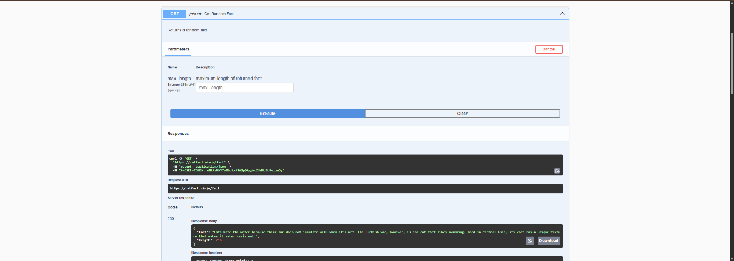
Figure 1: Swagger documentation showing GET /fact endpoint

Test 1: Random Cat Fact Request
The first request tested the basic random fact endpoint.
Request tested: GET https://catfact.ninja/fact
The API returned a successful 200 OK response and the response body was in JSON format.
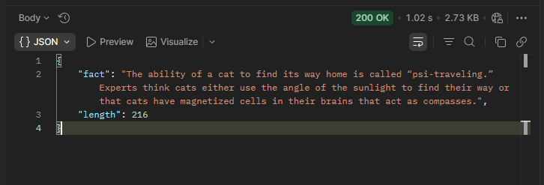
Figure 2: Postman GET request for Test 1
This confirmed that the endpoint was accessible and working correctly. The response only contained public cat fact data and did not expose sensitive information.

Test 2: Random Cat Fact Request with max_length parameter
The second request tested the max_length query parameter.
Request tested: GET https://catfact.ninja/fact?max_length=50
The purpose of this request was to check how the API handles a query parameter that controls the maximum length of the returned fact. The API returned a successful 200 OK response and provided a short cat fact within the length requested.
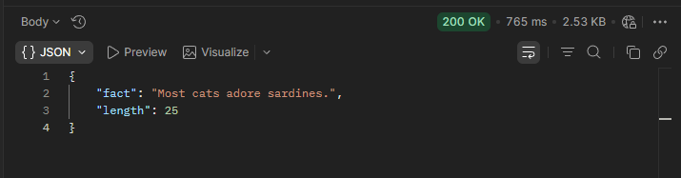
Figure 3: Postman GET request for Test 2
This showed that the API accepts user-controlled query parameters and uses them to control the response. From a security point of view, query parameters should always be validated by the server so unexpected input does not cause unsafe behaviour.

Test 3: Multiple Cat Facts Request
The third request tested the multiple facts endpoint with two query parameters.
Request tested: GET https://catfact.ninja/facts?max_length=70&limit=5
The API returned a successful 200 OK response. The response body contained multiple cat facts and pagination fields such as current_page, data, first_page_url, from and last_page etc.
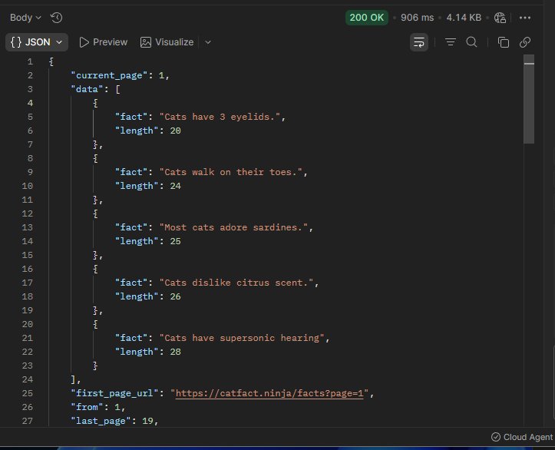
Figure 4: Postman GET request for Test 3
This response showed that the API can return multiple records at once. The returned data was still public and non-sensitive. No sensitive information was exposed in response body.

Test 4: Input Validation
An input validation was performed by sending an invalid value in the limit query parameter.
Request tested: GET https://catfact.ninja/facts?max_length=100&limit=a
The limit parameter is expected to be numeric because it controls the number of records returned. In this test, a non-integer value such as “a” was used instead.
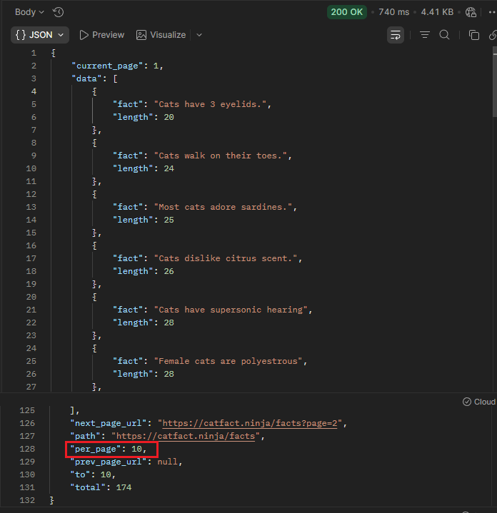
Figure 5: Postman GET request for Test 4
The API still returned a 200 OK response and provided random cat fact data. The response showed per_page: 10, which suggests that the API may ignore the invalid value and apply a default value instead of returning a validation error.
Since the API only returns public cat facts, the risk is low. However, from a secure API design perspective, invalid query parameters should be handled clearly. A safer approach would be to return a clear validation response such as 400 Bad Request without exposing internal system details.

Response Headers Review
Response headers were inspected in Postman to understand the API’s response behaviour and visible security controls.
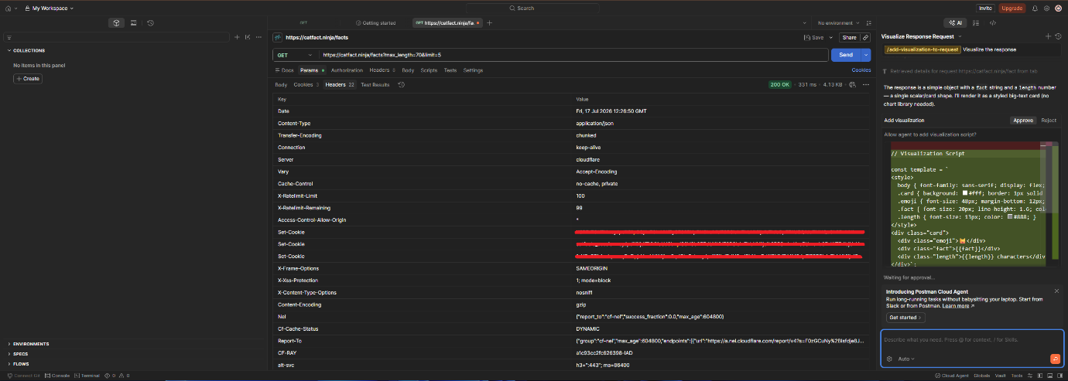
Figure 6: Postman response headers
The response headers showed that the API returned JSON data using Content-Type: application/json. The headers also showed rate limit information through X-RateLimit-Limit and X-RateLimit-Remaining. This is a positive finding because rate limiting helps reduce abuse of public APIs.
The response also included Access-Control-Allow-Origin: *, meaning the API allows browser-based requests from any origin. This is acceptable for a public API that returns non-sensitive data, but it would be risky for APIs that expose private user information.
Some cookie and session-related values were visible in the response headers, but they were redacted before being pushed to GitHub.

Authentication and Access Control Assessment
The Cat Facts API endpoints tested in this report did not require authentication. No API key, bearer token, username/password or OAuth token was required to access the tested endpoints.
In Postman, the requests were sent using No Auth. The request headers did not include Authorization, Bearer token or x-api-key headers.
This is acceptable for the Cat Facts API because it only returns public cat fact data. There is no sensitive user information, account data or private business data in the tested responses.
Access control testing was limited because the API does not provide user accounts, roles or private records. Since there are no user-specific resources, authorization issues such as accessing another user’s data were not applicable in this case.
The authentication and access control was classified and assessed as low.

Security Findings and Risk Analysis

Finding | Risk | Evidence | Explanation
Public unauthenticated access | Low | API requests worked without login or API key | The API is publicly accessible. This is acceptable because it only returns public cat facts, but public APIs should still use abuse protection.
No sensitive data exposed | Positive | Response body only included cat facts, length values and pagination details | The API did not expose passwords, tokens, private user data or confidential information in the response body.
Rate limiting present | Positive | Headers showed X-RateLimit-Limit and X-RateLimit-Remaining | Rate limiting helps reduce misuse of public APIs by limiting the number of requests.
CORS allows any origin | Low | Header showed Access-Control-Allow-Origin: * | This is acceptable for public data, but it is risky for APIs that return sensitive information.
Invalid query parameter accepted | Low | “limit=a” returned 200 OK | The API appeared to ignore the invalid value or use default behaviour. Clear validation would be better.
Token not required | Low | Postman Authorization tab used No Auth | No token is required because the API returns public data. This would be a concern if the API handled private data.
Authorization testing not applicable | Informational | No user accounts or private records were available | The API does not include user-specific access control features, so authorization testing was not applicable.

Business Impact
The overall business impact of the identified risks is low because the Cat Facts API only returns public non-sensitive information. The API does not expose user credentials or any private business data.
However, the findings are still useful from an API security perspective. Public APIs can still be misused if they don’t have proper controls. For example, missing or weak rate limiting could allow excessive automated requests. Weak input validation could create unexpected behaviour. Overly permissive CORS could become a risk if the API later starts returning sensitive data.
For a business environment, these risks would become more serious if the same design was used in an API that handled customer accounts, personal records or financial information or internal business data. In those cases, authentication, authorization, strict input validation, rate limiting and response minimization would be much more important.

Remediations

Area | Recommendation
Authentication | Continue allowing unauthenticated access only for public non-sensitive data. Use API keys or stronger authentication if private data is introduced.
Access Control | Add role-based or user-based access control if the API ever provides account-specific data.
Input Validation | Validate query parameters such as limit and max_length. Invalid values should return a safe error response.
Rate Limiting | Continue using rate limiting to reduce abuse of public endpoints.
CORS | Keep permissive CORS only for public data. Restrict allowed origins if sensitive features are added.
Response Data | Return only the fields required by the client and avoid unnecessary data exposure.
Header Security | Avoid exposing sensitive cookie or session values unnecessarily and ensure secure cookie flags are used where needed.
Error Handling | Return clear but safe error messages that don’t reveal internal system details.

Conclusion
This report analysed the Cat Facts API using Postman in a safe and read-only manner. The testing included API documentation review, successful GET requests, query parameter testing, response body inspection, response header inspection and a basic input validation test.
The API was found to be publicly accessible without authentication. This is acceptable for the current use case because the API only returns public cat fact data and doesn’t expose sensitive information. The response headers showed useful controls such as rate limiting, JSON content type and security-related headers.
The main improvement identified was input invalidation. When an invalid limit value was provided, the API still returned a 200 OK response and appeared to use normal behaviour. While this is low risk for a public cat facts API, stronger validation would be better from a secure API design perspective.
Overall, the Cat Facts API showed low security risk for this task. The analysis demonstrated how API security can be reviewed by inspecting authentication, access control, headers, responses, input parameters and possible business impact.

